**Guvi Day 19 Task**

**Project Folder Structure**

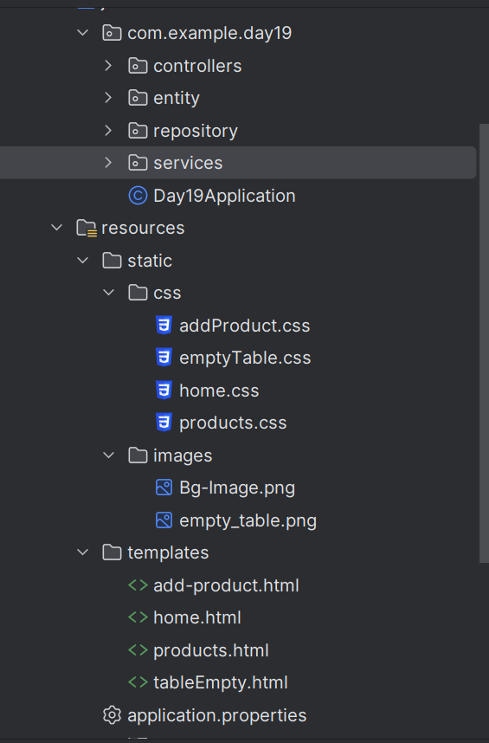

**Controllers**

**1. Product Controller**

package com.example.day19.controllers;  
import com.example.day19.entity.Product;  
import com.example.day19.services.Impl.ProductServiceImpl;  
import org.springframework.beans.factory.annotation.Autowired;  
import org.springframework.http.ResponseEntity;  
import org.springframework.stereotype.Controller;  
import org.springframework.ui.Model;  
import org.springframework.web.bind.annotation.*;  
  
import java.util.List;  
  
@Controller  
@RequestMapping("/products")  
public class ProductController {  
  
 @Autowired  
 private ProductServiceImpl productService;  
  
 @PostMapping  
 public ResponseEntity<Product> addProduct(@RequestBody Product product) {  
 Product savedProduct = productService.addProduct(product);  
 return ResponseEntity.*ok*(savedProduct);  
 }  
  
 @GetMapping  
 public ResponseEntity<List<Product>> viewProducts() {  
 List<Product> products = productService.getAllProducts();  
 return ResponseEntity.*ok*(products);  
 }  
  
 // Thymeleaf endpoint to render HTML view of products  
 @GetMapping("/view")  
 public String viewProductsPage(Model model) {  
 List<Product> products = productService.getAllProducts();  
 if(!products.isEmpty()){  
 model.addAttribute("products", products);  
 return "products";  
 }  
 return "tableEmpty";  
 }  
 // Thymeleaf endpoint to render HTML form for adding a product  
 @GetMapping("/add")  
 public String addProductPage(Model model) {  
 model.addAttribute("product", new Product());  
 return "add-product";  
 }  
 @PostMapping("/add")  
 public String addProductForm(Product product) {  
 productService.addProduct(product);  
 return "redirect:/products/view";  
 }  
}

**2. Home Controller**

package com.example.day19.controllers;  
  
import org.springframework.stereotype.Controller;  
import org.springframework.web.bind.annotation.GetMapping;  
import org.springframework.web.bind.annotation.RequestMapping;  
  
@Controller  
@RequestMapping("/")  
public class HomeController {  
  
 @GetMapping()  
 public String Home(){  
 return "home";  
 }  
}

**Entity ( Product )**

package com.example.day19.entity;  
  
import jakarta.persistence.Entity;  
import jakarta.persistence.GeneratedValue;  
import jakarta.persistence.GenerationType;  
import jakarta.persistence.Id;  
import lombok.AllArgsConstructor;  
import lombok.Data;  
import lombok.NoArgsConstructor;  
  
import java.util.List;  
  
@Entity  
@Data  
@AllArgsConstructor  
@NoArgsConstructor  
public class Product {  
  
 @Id  
 @GeneratedValue(strategy = GenerationType.*IDENTITY*)  
 private Long id;  
  
 private String name;  
 private Double price;  
 private Integer discount;  
 private String category;  
 private Integer quantity;  
 private String condition;  
 private String mainImageURL;  
}

**Service**

**1. Service Interface**

package com.example.day19.services;  
  
import com.example.day19.entity.Product;  
  
import java.util.List;  
  
public interface ProductService {  
 public Product addProduct(Product product);  
  
 public List<Product> getAllProducts();  
}

**2. Service Class**

package com.example.day19.services.Impl;  
import com.example.day19.entity.Product;  
import com.example.day19.repository.ProductRepository;  
import com.example.day19.services.ProductService;  
import org.springframework.beans.factory.annotation.Autowired;  
import org.springframework.stereotype.Service;  
import java.util.List;  
  
@Service  
public class ProductServiceImpl implements ProductService {  
 @Autowired  
 private ProductRepository productRepository;  
 @Override  
 public Product addProduct(Product product) {  
 return productRepository.save(product);  
 }  
  
 @Override  
 public List<Product> getAllProducts() {  
 return productRepository.findAll();  
 }  
}

**Repository**

**JPA Repository**

package com.example.day19.repository;  
  
import com.example.day19.entity.Product;  
import org.springframework.data.jpa.repository.JpaRepository;  
import org.springframework.stereotype.Repository;  
  
@Repository  
public interface ProductRepository extends JpaRepository<Product,Long> {  
}

**Html Pages**

**1. Home Page**

<!DOCTYPE html>  
<html xmlns:th="http://www.thymeleaf.org">  
<head>  
 <meta charset="UTF-8">  
 <title>Home</title>  
 <link th:href="@{/css/home.css}" rel="stylesheet" />  
</head>  
<body>  
 <h1>Welcome !</h1>  
 <div class="divide_line"></div>  
 <p>Lorem ipsum dolor sit amet consectetur adipisicing elit. Quo,obcaecati nulla </p>  
 <p> vitae, maxime veniam id non quod sunt iusto fugiat sapiente consequatur </p>  
 <p> velit nostrum ex, consectetur eligendi dolor architecto! Aut?</p>  
  
 <div class="buttons_div">  
 <a href="/products/view" class="display_product_btn">Display Product</a>  
 <a href="/products/add" class="add_product_btn">Add Product</a>  
 </div>  
</body>  
</html>

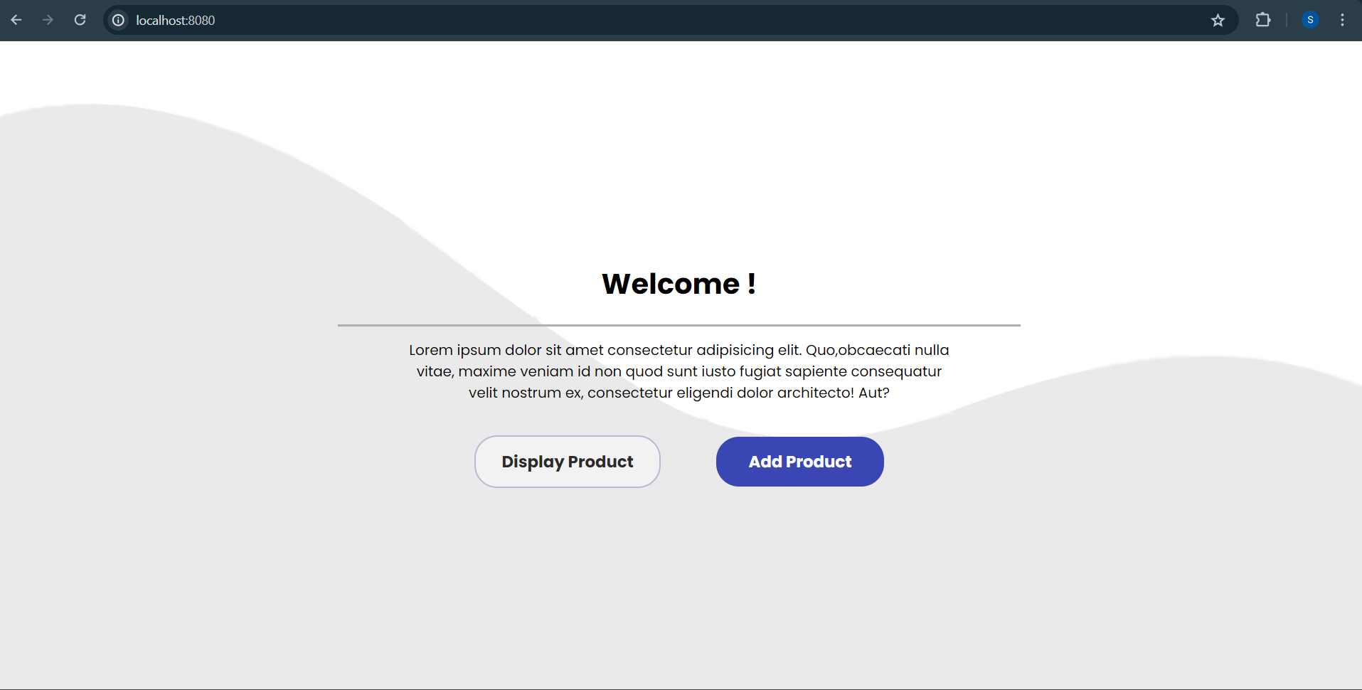

**2. View Products Page**

<!DOCTYPE html>  
<html xmlns:th="http://www.thymeleaf.org">  
<head>  
 <title>Products</title>  
 <link th:href="@{/css/products.css}" rel="stylesheet" />  
 <link href="https://cdn.jsdelivr.net/npm/bootstrap@5.3.3/dist/css/bootstrap.min.css" rel="stylesheet" integrity="sha384-QWTKZyjpPEjISv5WaRU9OFeRpok6YctnYmDr5pNlyT2bRjXh0JMhjY6hW+ALEwIH" crossorigin="anonymous">  
 <link rel="stylesheet" href="https://cdnjs.cloudflare.com/ajax/libs/font-awesome/6.5.2/css/all.min.css" integrity="sha512-SnH5WK+bZxgPHs44uWIX+LLJAJ9/2PkPKZ5QiAj6Ta86w+fsb2TkcmfRyVX3pBnMFcV7oQPJkl9QevSCWr3W6A==" crossorigin="anonymous" referrerpolicy="no-referrer" />  
</head>  
<body>  
<h2>Products</h2>  
<table th:class="product_table">  
 <tr>  
 <th>ID</th>  
 <th>Image</th>  
 <th>Name</th>  
 <th>Price</th>  
 <th>Discount</th>  
 <th>Category</th>  
 <th>Quantity</th>  
 <th>Condition</th>  
 </tr>  
 <tr th:each="product : ${products}">  
 <td th:text="${product.id}">ID</td>  
 <td>  
 <img th:src="@{${product.mainImageURL}}" style="width: 40px; height: 50px;" alt="Product Image" />  
 </td>  
 <td th:text="${product.name}">Name</td>  
 <td th:text="'₹ ' + ${product.price}">Price</td>  
 <td th:text="${product.discount} + '%' ">Discount</td>  
 <td th:text="${product.category}">Category</td>  
 <td th:text="${product.quantity}">Quantity</td>  
 <td th:text="${product.condition}">Condition</td>  
 </tr>  
</table>  
  
 <a href="/products/add" class="addProductBTN">  
 <span><i class="fa-solid fa-plus"></i></span>  
 <span class="HoveraddProduct">Add Product</span>  
 </a>  
</body>  
</html>

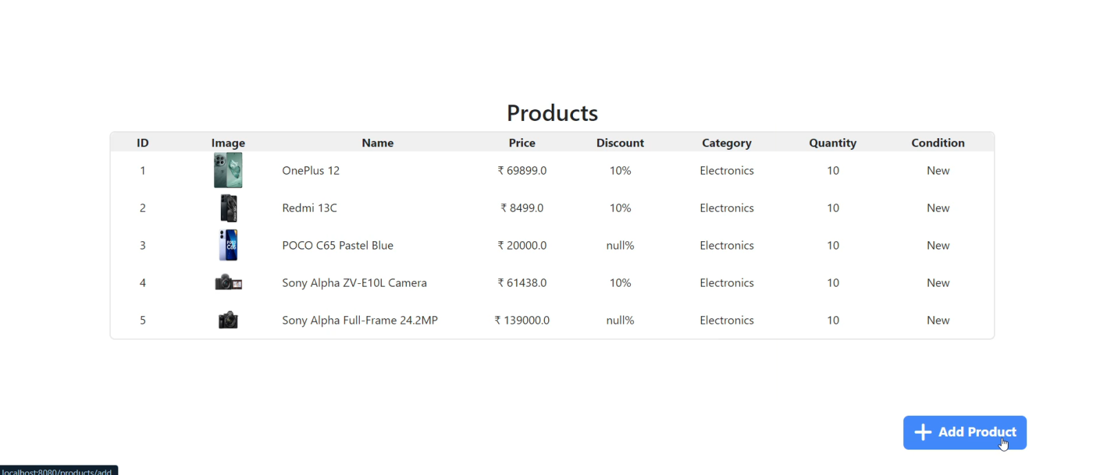

**3. Add Product Page**

<!DOCTYPE html>  
<html xmlns:th="http://www.thymeleaf.org">  
<head>  
 <title>Add Product</title>  
 <link th:href="@{/css/addProduct.css}" rel="stylesheet" />  
 <link href="https://cdn.jsdelivr.net/npm/bootstrap@5.3.3/dist/css/bootstrap.min.css" rel="stylesheet" integrity="sha384-QWTKZyjpPEjISv5WaRU9OFeRpok6YctnYmDr5pNlyT2bRjXh0JMhjY6hW+ALEwIH" crossorigin="anonymous">  
 <link rel="stylesheet" href="https://cdnjs.cloudflare.com/ajax/libs/font-awesome/6.5.2/css/all.min.css" integrity="sha512-SnH5WK+bZxgPHs44uWIX+LLJAJ9/2PkPKZ5QiAj6Ta86w+fsb2TkcmfRyVX3pBnMFcV7oQPJkl9QevSCWr3W6A==" crossorigin="anonymous" referrerpolicy="no-referrer" />  
</head>  
<body>  
<form th:class="form_container" th:action="@{/products/add}" th:object="${product}" method="post">  
 <h4 class="heading">Add new Product</h4>  
 <a id="close_icon" href="/products/view" class="fa-solid fa-xmark"></a>  
  
 <!-- Product Name-->  
  
 <div th:class="input_container">  
 <label for="name">Name:</label>  
 <input th:class="input_field" placeholder="Eg. Samsung Galaxy S24 Ultra" type="text" id="name" th:field="*{name}" required />  
 </div>  
  
 <!-- Product Price & Discount -->  
 <div class="dual_input_container">  
 <div th:class="input_container">  
 <label for="price">Price:</label>  
 <input th:class="input_field" type="number" id="price" th:field="*{price}" placeholder="Enter amount" required/>  
 </div>  
 <div th:class="input_container">  
 <label for="discount">Discount % <span>(optional)</span> </label>  
 <input th:class="input_field" type="number" id="discount" th:field="*{discount}" placeholder="Enter discount %" />  
 </div>  
 </div>  
  
 <!-- Product Category -->  
 <div th:class="input_container">  
 <label for="category">Select Category:</label>  
 <select class="input_field" id="category" th:field="*{category}" required>  
 <option value="Fashion">Fashion</option>  
 <option value="Home_and_Kitchen">Home & Kitchen</option>  
 <option value="Electronics">Electronics Appliances</option>  
 <option value="Books_and_Entertainment">Books & Entertainment</option>  
 </select>  
 </div>  
  
 <!-- Product Quantity & Condition -->  
 <div class="dual_input_container">  
 <div th:class="input_container">  
 <label for="quantity">Quantity:</label>  
 <input th:class="input_field" type="number" id="quantity" th:field="*{quantity}" placeholder="0" required/>  
 </div>  
 <div th:class="input_container">  
 <label for="condition">Condition Type:</label>  
 <select class="input_field" id="condition" th:field="*{condition}" required>  
 <option value="New">New</option>  
 <option value="Used">Used</option>  
 </select>  
 </div>  
 </div>  
  
 <!-- Product Main Image URL -->  
 <div th:class="input_container">  
 <label for="imageURL">Main Image URL:</label>  
 <input th:class="input_field" type="text" id="imageURL" th:field="*{mainImageURL}" placeholder="Eg. https://www.example.com" required/>  
 </div>  
  
  
 <button th:class="submit_btn" type="submit">Add Product</button>  
  
</form>  
  
</body>  
</html>

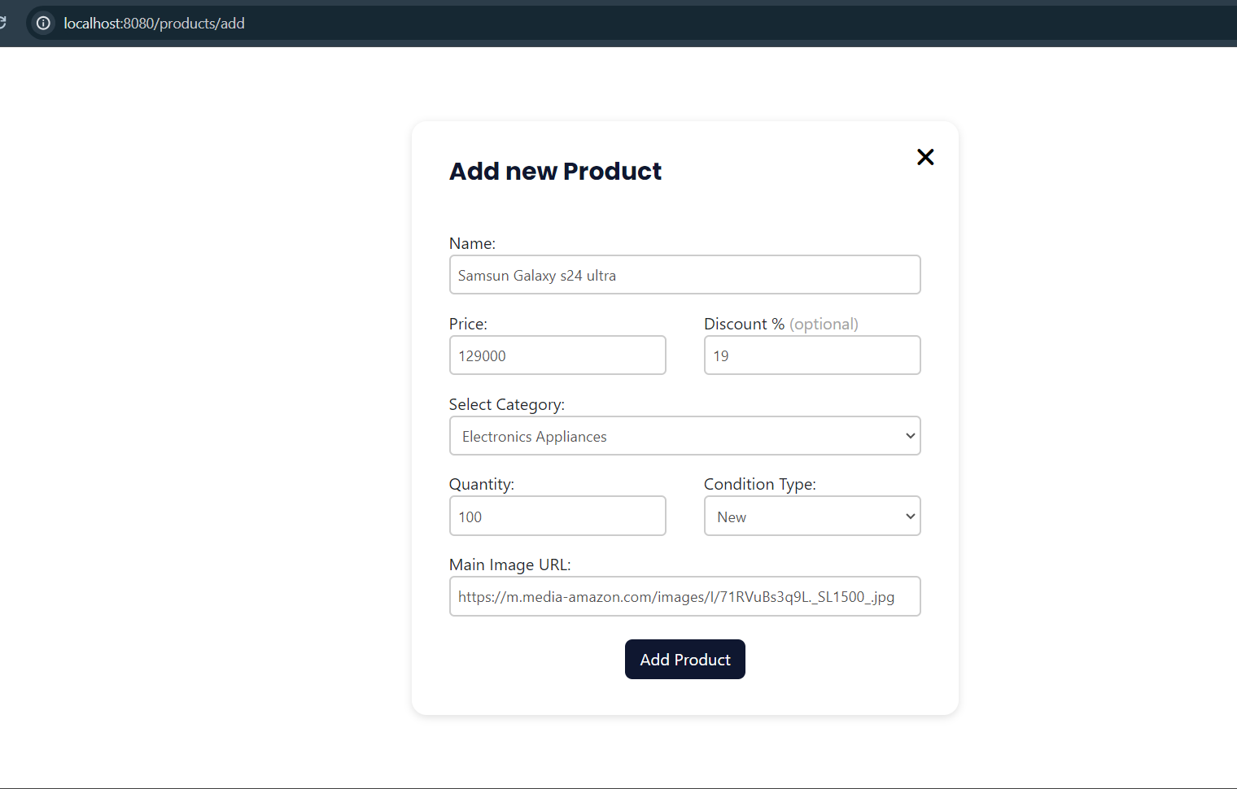

**Empty Table**

<!DOCTYPE html>  
<html xmlns:th="http://www.thymeleaf.org">  
<head>  
 <meta charset="UTF-8">  
 <title>Title</title>  
 <link th:href="@{/css/emptyTable.css}" rel="stylesheet" />  
 <link th:href="@{/css/products.css}" rel="stylesheet" />  
 <link href="https://cdn.jsdelivr.net/npm/bootstrap@5.3.3/dist/css/bootstrap.min.css" rel="stylesheet" integrity="sha384-QWTKZyjpPEjISv5WaRU9OFeRpok6YctnYmDr5pNlyT2bRjXh0JMhjY6hW+ALEwIH" crossorigin="anonymous">  
 <link rel="stylesheet" href="https://cdnjs.cloudflare.com/ajax/libs/font-awesome/6.5.2/css/all.min.css" integrity="sha512-SnH5WK+bZxgPHs44uWIX+LLJAJ9/2PkPKZ5QiAj6Ta86w+fsb2TkcmfRyVX3pBnMFcV7oQPJkl9QevSCWr3W6A==" crossorigin="anonymous" referrerpolicy="no-referrer" />  
</head>  
<body th:class="body_wrapper">  
  
  
 <a href="/products/add" class="addProductBTN">  
 <span><i class="fa-solid fa-plus"></i></span>  
 <span class="HoveraddProduct">Add Product</span>  
 </a>  
</body>  
</html>

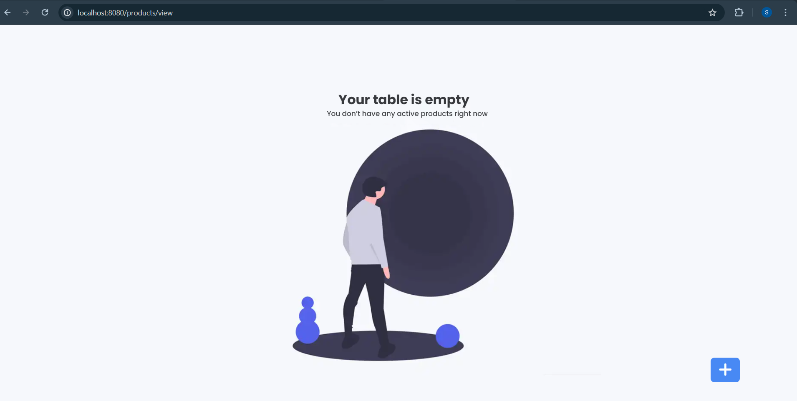

**Application Properties**

spring.application.name=day19  
spring.datasource.url=jdbc:h2:mem:testdb  
spring.datasource.driverClassName=org.h2.Driver  
spring.datasource.username=user  
spring.datasource.password=password  
spring.jpa.database-platform=org.hibernate.dialect.H2Dialect  
spring.h2.console.enabled=true  
spring.datasource.path=/h2-console  
  
spring.devtools.livereload.enabled=true  
spring.devtools.restart.enabled=true